Campaign Management

Data Setup

# Modify Scripts for Quick Execution

For the purposes of a quick demo, we need to use a small dataset. To create a smaller dataset follow the below steps. (This will modify the data size when using the SQLR solution path or the Powershell solution path.)

1. *Open step1(c)_lead_demography.sql. Press Ctrl + G. Enter 55 and press Enter. This will take you to the 55th line of the code. Change the value 100000 to 10000 for the purpose of a quick demo*

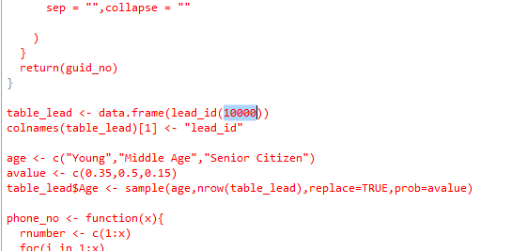

1. *Open Step5(a)_model_train_rf.sql*. *Press Ctrl + G. Enter 48 and press Enter. This will take you to the 48th line of the code. Change the value 500 to 75 for the purpose of a quick demo*

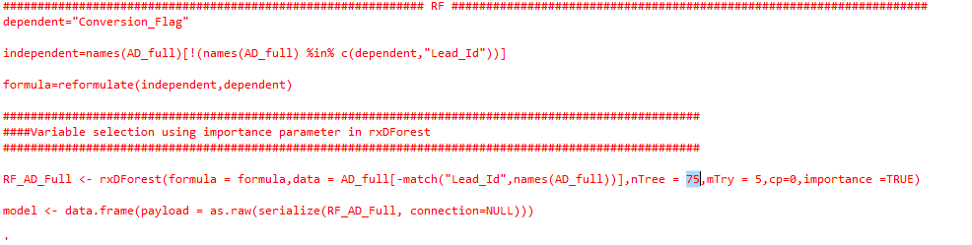

1. *Open Step5(c)_model_train_gbm.sql*. *Press Ctrl + G. Enter 64 and press Enter. This will take you to the 64th line of the code. Change the value 500 to 75 for the purpose of a quick demo*

